Федеральное государственное автономное образовательное учреждение высшего образования

Университет ИТМО

**Факультет программной инженерии**

**Образовательная программа СППО**

**Курсовая работа**

Вариант 31

Выполнил: **Нуруллаев Даниил Романович**Группа: **Р3114**

**Санкт-Петербург**

**2020г**

|  |  |
| --- | --- |
| **Условие f = 1** | **Условие f = d** |
| **4<(X1X2+X3X4X5)<=8** | **(X3X4X5)=2** |

**Часть 1**

1. **Составление таблицы истинности**

|  |  |  |  |  |  |  |  |  |  |  |  |  |  |  |
| --- | --- | --- | --- | --- | --- | --- | --- | --- | --- | --- | --- | --- | --- | --- |
| № | X1 | X2 | X3 | X4 | X5 | X1X2 | | (X1X2)10 | X3X4X5 | | | (X3X4X5)10 | | +| | **F** |
| 1 | 0 | 0 | 0 | 0 | 0 | 0 | 0 | 0 | 0 | 0 | 0 | 0 | 0 | **0** |
| 2 | 0 | 0 | 0 | 0 | 1 | 0 | 0 | 0 | 0 | 0 | 1 | 1 | 1 | **0** |
| 3 | 0 | 0 | 0 | 1 | 0 | 0 | 0 | 0 | 0 | 1 | 0 | 2 | 2 | **D** |
| 4 | 0 | 0 | 0 | 1 | 1 | 0 | 0 | 0 | 0 | 1 | 1 | 3 | 3 | **0** |
| 5 | 0 | 0 | 1 | 0 | 0 | 0 | 0 | 0 | 1 | 0 | 0 | 4 | 4 | **0** |
| 6 | 0 | 0 | 1 | 0 | 1 | 0 | 0 | 0 | 1 | 0 | 1 | 5 | 5 | **1** |
| 7 | 0 | 0 | 1 | 1 | 0 | 0 | 0 | 0 | 1 | 1 | 0 | 6 | 6 | **1** |
| 8 | 0 | 0 | 1 | 1 | 1 | 0 | 0 | 0 | 1 | 1 | 1 | 7 | 7 | **1** |
| 9 | 0 | 1 | 0 | 0 | 0 | 0 | 1 | 1 | 0 | 0 | 0 | 0 | 1 | **0** |
| 10 | 0 | 1 | 0 | 0 | 1 | 0 | 1 | 1 | 0 | 0 | 1 | 1 | 2 | **0** |
| 11 | 0 | 1 | 0 | 1 | 0 | 0 | 1 | 1 | 0 | 1 | 0 | 2 | 3 | **D** |
| 12 | 0 | 1 | 0 | 1 | 1 | 0 | 1 | 1 | 0 | 1 | 1 | 3 | 4 | **0** |
| 13 | 0 | 1 | 1 | 0 | 0 | 0 | 1 | 1 | 1 | 0 | 0 | 4 | 5 | **1** |
| 14 | 0 | 1 | 1 | 0 | 1 | 0 | 1 | 1 | 1 | 0 | 1 | 5 | 6 | **1** |
| 15 | 0 | 1 | 1 | 1 | 0 | 0 | 1 | 1 | 1 | 1 | 0 | 6 | 7 | **1** |
| 16 | 0 | 1 | 1 | 1 | 1 | 0 | 1 | 1 | 1 | 1 | 1 | 7 | 8 | **1** |
| 17 | 1 | 0 | 0 | 0 | 0 | 1 | 0 | 2 | 0 | 0 | 0 | 0 | 2 | **0** |
| 18 | 1 | 0 | 0 | 0 | 1 | 1 | 0 | 2 | 0 | 0 | 1 | 1 | 3 | **0** |
| 19 | 1 | 0 | 0 | 1 | 0 | 1 | 0 | 2 | 0 | 1 | 0 | 2 | 4 | **D** |
| 20 | 1 | 0 | 0 | 1 | 1 | 1 | 0 | 2 | 0 | 1 | 1 | 3 | 5 | **1** |
| 21 | 1 | 0 | 1 | 0 | 0 | 1 | 0 | 2 | 1 | 0 | 0 | 4 | 6 | **1** |
| 22 | 1 | 0 | 1 | 0 | 1 | 1 | 0 | 2 | 1 | 0 | 1 | 5 | 7 | **1** |
| 23 | 1 | 0 | 1 | 1 | 0 | 1 | 0 | 2 | 1 | 1 | 0 | 6 | 8 | **1** |
| 24 | 1 | 0 | 1 | 1 | 1 | 1 | 0 | 2 | 1 | 1 | 1 | 7 | 9 | **0** |
| 25 | 1 | 1 | 0 | 0 | 0 | 1 | 1 | 3 | 0 | 0 | 0 | 0 | 3 | **0** |
| 26 | 1 | 1 | 0 | 0 | 1 | 1 | 1 | 3 | 0 | 0 | 1 | 1 | 4 | **0** |
| 27 | 1 | 1 | 0 | 1 | 0 | 1 | 1 | 3 | 0 | 1 | 0 | 2 | 5 | **d** |
| 28 | 1 | 1 | 0 | 1 | 1 | 1 | 1 | 3 | 0 | 1 | 1 | 3 | 6 | **1** |
| 29 | 1 | 1 | 1 | 0 | 0 | 1 | 1 | 3 | 1 | 0 | 0 | 4 | 7 | **1** |
| 30 | 1 | 1 | 1 | 0 | 1 | 1 | 1 | 3 | 1 | 0 | 1 | 5 | 8 | **1** |
| 31 | 1 | 1 | 1 | 1 | 0 | 1 | 1 | 3 | 1 | 1 | 0 | 6 | 9 | **0** |
| 32 | 1 | 1 | 1 | 1 | 1 | 1 | 1 | 3 | 1 | 1 | 1 | 7 | 10 | **0** |

**2.Представить булевую функцию в аналитическом виде с помощью КДНФ и ККНФ**

КДНФ: ƒ = 12X34X5 v 12X3X45 v 12X3X4X5 v 1X2X345 v 1X2X34X5 v

v 1X2X345 v 1X2X345 v 12345 v12X345 v 12X345 v12X345 v 12345 v X1X2X345 v X1X2X34X5

ККНФ: ƒ = (X1 v X2 v X3 v X4 v X5)(X1 v X2 v X3 v 4 v 5)(X1 v X2 v X3 v 4 v 5)

(X1 v 2 v 3 v X4 v 5)(X1 v 2 v X3 v X4 v 5)(X1 v 2 v 3 v X4 v 5)(X1 v 2 v 3 v 4 v 5)

(1 v 2 v 3 v 4 v X5) (1 v 2 v 3 v 4 v5)(1 v X2 v 3 v 4 v 5)(1 v 2 v 3 v X4 v X5)

(1 v 2 v X3 v X4 v 5)(1 v 2 v 3 v 4 v X5)(1 v 2 v 3 v 4 v 5)

1. **Минимизация булевой функции методом Квайна-Мак-Класки**

Нахождение простых импликант (максимальных кубов):

|  |  |  |  |  |  |  |  |  |  |  |  |  |
| --- | --- | --- | --- | --- | --- | --- | --- | --- | --- | --- | --- | --- |
| Ko(ƒ)  N(ƒ) | | | K1(ƒ) | | | | K2(ƒ) | | | | Z(ƒ) | |
| 1 | 00010 | + | 1 | 00x10 | 1-3 | + | 1 | 0xx10 | 1-11 |  | 1 | 101x0 |
| 2 | 00101 | + | 2 | 0x010 | 1-5 | + | 2 | X0x10 | 1-20 |  | 2 | 0xx10 |
| 3 | 00110 | + | 3 | X0010 | 1-10 | + | 3 | xx010 | 2-21 |  | 3 | X0x10 |
| 4 | 00111 | + | 4 | 001x1 | 2-4 | + | 4 | 0x1x1 | 4-16 |  | 4 | Xx010 |
| 5 | 01010 | + | 5 | 0x101 | 2-7 | + | 5 | Xx101 | 5-26 |  | 5 | 0x1x1 |
| 6 | 01100 | + | 6 | X0101 | 2-13 | + | 6 | 0x11x | 7-18 |  | 6 | Xx101 |
| 7 | 01101 | + | 7 | 0011x | 3-4 | + | 7 | 011xx | 13-18 |  | 7 | 0x11x |
| 8 | 01110 | + | 8 | 0x110 | 3-8 | + | 8 | X110x | 13-28 |  | 8 | 011xx |
| 9 | 01111 | + | 9 | X0110 | 3-14 | + | 9 | 1x01x | 19-27 |  | 9 | X110x |
| 10 | 10010 | + | 10 | 0x111 | 4-9 | + | 10 | 1x10x | 23-28 |  | 10 | 1x01x |
| 11 | 10011 | + | 11 | 01x10 | 5-8 | + |  |  |  |  | 11 | 1x10x |
| 12 | 10100 | + | 12 | X1010 | 5-15 | + |  |  |  |  |  |  |
| 13 | 10101 | + | 13 | 0110x | 6-7 | + |  |  |  |  |  |  |
| 14 | 10110 | + | 14 | 011x0 | 6-8 | + |  |  |  |  |  |  |
| 15 | 11010 | + | 15 | X1100 | 6-17 | + |  |  |  |  |  |  |
| 16 | 11011 | + | 16 | 011x1 | 7-9 | + |  |  |  |  |  |  |
| 17 | 11100 | + | 17 | X1101 | 7-18 | + |  |  |  |  |  |  |
| 18 | 11101 | + | 18 | 0111x | 8-9 | + |  |  |  |  |  |  |
|  |  |  | 19 | 1001x | 10-11 | + |  |  |  |  |  |  |
|  |  |  | 20 | 10x10 | 10-14 | + |  |  |  |  |  |  |
|  |  |  | 21 | 1x010 | 10-15 | + |  |  |  |  |  |  |
|  |  |  | 22 | 1x011 | 11-16 | + |  |  |  |  |  |  |
|  |  |  | 23 | 1010x | 12-13 | + |  |  |  |  |  |  |
|  |  |  | 24 | 101x0 | 12-14 |  |  |  |  |  |  |  |
|  |  |  | 25 | 1x100 | 12-17 | + |  |  |  |  |  |  |
|  |  |  | 26 | 1x101 | 13-18 | + |  |  |  |  |  |  |
|  |  |  | 27 | 1101x | 15-16 | + |  |  |  |  |  |  |
|  |  |  | 28 | 1110x | 17-18 | + |  |  |  |  |  |  |

Импликантная таблица:

|  |  |  |  |  |  |  |  |  |  |  |  |  |  |  |
| --- | --- | --- | --- | --- | --- | --- | --- | --- | --- | --- | --- | --- | --- | --- |
|  | 0-кубы | | | | | | | | | | | | | |
| Импликанты | 0  0  1  0  1 | 0  0  1  1  0 | 0  0  1  1  1 | 0  1  1  0  0 | 0  1  1  0  1 | 0  1  1  1  0 | 0  1  1  1  1 | 1  0  0  1  1 | 1  0  1  0  0 | 1  0  1  0  1 | 1  0  1  1  0 | 1  1  0  1  1 | 1  1  1  0  0 | 1  1  1  0  1 |
|  | 1 | 2 | 3 | 4 | 5 | 6 | 7 | 8 | 9 | 10 | 11 | 12 | 13 | 14 |
| 1. 101x0 |  |  |  |  |  |  |  |  | ✶ |  | ✶ |  |  |  |
| 1. 0xx10 |  | ✶ |  |  |  | ✶ |  |  |  |  |  |  |  |  |
| 1. X0x10 |  | ✶ |  |  |  |  |  |  |  |  | ✶ |  |  |  |
| 1. Xx010 |  |  |  |  |  |  |  |  |  |  |  |  |  |  |
| 1. 0x1x1 | ✶ |  | ✶ |  | ✶ |  | ✶ |  |  |  |  |  |  |  |
| 1. Xx101 | ✶ |  |  |  | ✶ |  |  |  |  | ✶ |  |  |  | ✶ |
| 1. 0x11x |  | ✶ | ✶ |  |  | ✶ | ✶ |  |  |  |  |  |  |  |
| 1. 011xx |  |  |  | ✶ | ✶ | ✶ | ✶ |  |  |  |  |  |  |  |
| 1. X110x |  |  |  | ✶ | ✶ |  |  |  |  |  |  |  | ✶ | ✶ |
| 1. 1x01x |  |  |  |  |  |  |  | ✶ |  |  |  | ✶ |  |  |
| 1. 1x10x |  |  |  |  |  |  |  |  | ✶ | ✶ |  |  | ✶ | ✶ |

Существенные импликанты:

|  |  |  |  |  |  |  |  |  |  |  |  |  |  |
| --- | --- | --- | --- | --- | --- | --- | --- | --- | --- | --- | --- | --- | --- |
|  | 0-кубы | | | | | | | | | | | | |
| Импликанты |  | 0  0  1  0  1 | 0  0  1  1  0 | 0  0  1  1  1 | 0  1  1  0  0 | 0  1  1  0  1 | 0  1  1  1  0 | 0  1  1  1  1 | 1  0  1  0  0 | 1  0  1  0  1 | 1  0  1  1  0 | 1  1  1  0  0 | 1  1  1  0  1 |
|  |  | a | b | c | d | e | f | g | h | i | j | k | l |
| 1. 101x0 | A |  |  |  |  |  |  |  | ✶ |  | ✶ |  |  |
| 1. 0xx10 | B |  | ✶ |  |  |  | ✶ |  |  |  |  |  |  |
| 1. X0x10 | C |  | ✶ |  |  |  |  |  |  |  | ✶ |  |  |
| 1. 0x1x1 | D | ✶ |  | ✶ |  | ✶ |  | ✶ |  |  |  |  |  |
| 1. Xx101 | E | ✶ |  |  |  | ✶ |  |  |  | ✶ |  |  | ✶ |
| 1. 0x11x | F |  | ✶ | ✶ |  |  | ✶ | ✶ |  |  |  |  |  |
| 1. 011xx | G |  |  |  | ✶ | ✶ | ✶ | ✶ |  |  |  |  |  |
| 1. X110x | H |  |  |  | ✶ | ✶ |  |  |  |  |  | ✶ | ✶ |
| 1. 1x10x | I |  |  |  |  |  |  |  | ✶ | ✶ |  | ✶ | ✶ |

Множество существенных импликант (максимальных кубов) образует ядро покрытия как его обязательную часть:

#### T=

Определение минимального покрытия:

Y=(D∨E)(B∨C∨F)(D∨F)(G∨H)(D∨EVGVH)(B∨FVG)(D∨F∨G)(A∨I) (EVI)(AVC)(HVI)(EVHVI)

Y=CDGI v AEFH v AEFGI v BCDHI v ABDGI v ADFGI v ADFHI v CDFHI v CEFGI v ABDHI v CEFHI v ABDEH v ACDEGH

Минимальное покрытие функции – С1

Этому покрытию соответствует МДНФ следующего вида:

F=X13X4 v 2X45 v 1X3X5 v 1X2X3 v X1X34

Число букв в МДНФ совпадает с ценой покрытия Sa, а суммарное число букв и число термов совпадает с ценой покрытия Sb.

1. **Минимизация булевой функции на картах Карно**

**Определение МДНФ**

Для минимизации булевой функции от пяти переменных используем две четырехмерные карты Карно, различающиеся по переменной X1: (единичные покрытия)

|  |  |  |  |  |  |  |  |  |  |  |  |  |  |  |  |  |  |  |  |  |  |  |  |  |  |  |  |  |  |  |  |  |  |  |  |  |  |  |  |  |  |  |  |  |  |  |  |  |  |  |  |  |  |  |  |  |  |  |  |  |  |  |  |  |  |  |  |  |  |  |  |  |  |  |  |
| --- | --- | --- | --- | --- | --- | --- | --- | --- | --- | --- | --- | --- | --- | --- | --- | --- | --- | --- | --- | --- | --- | --- | --- | --- | --- | --- | --- | --- | --- | --- | --- | --- | --- | --- | --- | --- | --- | --- | --- | --- | --- | --- | --- | --- | --- | --- | --- | --- | --- | --- | --- | --- | --- | --- | --- | --- | --- | --- | --- | --- | --- | --- | --- | --- | --- | --- | --- | --- | --- | --- | --- | --- | --- | --- | --- |
| |  |  |  |  |  |  | | --- | --- | --- | --- | --- | --- | |  | X4X5 | | | | | | X2X3 |  | **00** | **01** | **11** | **10** | | **00** |  |  |  | d | | **01** |  | 1 | 1 | 1 | | **11** | 1 | 1 | 1 | 1 | | **10** |  |  |  | d | | X1 = 0 | | | | | | |  |  |  |  |  |  | | --- | --- | --- | --- | --- | --- | |  | X4X5 | | | | | | X2X3 |  | **00** | **01** | **11** | **10** | | **00** |  |  | 1 | d | | **01** | 1 | 1 |  | 1 | | **11** | 1 | 1 |  |  | | **10** |  |  | 1 | d | | X1 = 1 | | | | | |

Цены минимальных покрытий, полученных методом Квайна Мак-Класски и с помощью карт Карно, совпадают, так как цена мин. покрытия булевой функции не зависит от метода ее нахождения.

МДНФ имеет следующий вид:

F=X13X4 v 2X45 v 1X3X5 v 1X2X3 v X1X34

**Определение МКНФ**

|  |  |  |  |  |  |  |  |  |  |  |  |  |  |  |  |  |  |  |  |  |  |  |  |  |  |  |  |  |  |  |  |  |  |  |  |  |  |  |  |  |  |  |  |  |  |  |  |  |  |  |  |  |  |  |  |  |  |  |  |  |  |  |  |  |  |  |  |  |  |  |  |  |  |  |  |
| --- | --- | --- | --- | --- | --- | --- | --- | --- | --- | --- | --- | --- | --- | --- | --- | --- | --- | --- | --- | --- | --- | --- | --- | --- | --- | --- | --- | --- | --- | --- | --- | --- | --- | --- | --- | --- | --- | --- | --- | --- | --- | --- | --- | --- | --- | --- | --- | --- | --- | --- | --- | --- | --- | --- | --- | --- | --- | --- | --- | --- | --- | --- | --- | --- | --- | --- | --- | --- | --- | --- | --- | --- | --- | --- | --- |
| |  |  |  |  |  |  | | --- | --- | --- | --- | --- | --- | |  | X4X5 | | | | | | X2X3 |  | **00** | **01** | **11** | **10** | | **00** | 0 | 0 | 0 | d | | **01** | 0 |  |  |  | | **11** |  |  |  |  | | **10** | 0 | 0 | 0 | d | | X1 = 0 | | | | | | |  |  |  |  |  |  | | --- | --- | --- | --- | --- | --- | |  | X4X5 | | | | | | X2X3 |  | **00** | **01** | **11** | **10** | | **00** | 0 | 0 |  | d | | **01** |  |  | 0 |  | | **11** |  |  | 0 | 0 | | **10** | 0 | 0 |  | d | | X1 = 1 | | | | | |

*Минимальное нулевое покрытие определяется по тем же принципам, что и единичное, но обозначается .Минимальное нулевое покрытие определяется по тем же принципам, что и единичное, но обозначается .*

МKНФ имеет следующий вид:

F=(X1 v X3)*(X1 v X2 v X4 v X5)*(1 v X3 v X4)*(1 v 3 v 4 v 5)*(1 v 2 v 3 v 4)

**5.Преобразование минимальных форм булевой функции**

**Факторное преобразование для МДНФ**

F=X13X4 v 2X45 v 1X3X5 v 1X2X3 v X1X34  (SQ=20)

F=X4(X13 v25 )v 1X3(X5 v X2 ) v X1X34  (SQ=19)

Далее факторное преобразование и декомпозиция нецелесообразны.

Мы получили , но задержка увеличилась до 4t.

**Факторное преобразование для МКНФ**

F=(X1 v X3)*(X1 v X2 v X4 v X5)*(1 v X3 v X4)*(1 v 3 v 4 v 5)*(1 v 2 v 3 v 4) (SQ=22)

F=(X1 v X3*( X2 v X4 v X5))*(1 v X3 v X4)*(1 v 3 v 4 v 2 *5) (SQ=19)

ϕ =2 *5

F=(X1 v X3*( v X4 ))*(1 v X3 v X4)*(1 v 3 v 4 v) (SfQ=17,SфQ=2)

Мы получили , но задержка увеличилась до 4t.

**6.Построение комбинационной схемы**

F=X4(X13 v25 )v 1X3(X5 v X2 ) v X1X34

Построение схемы в булевом базисе с парафазными входами:

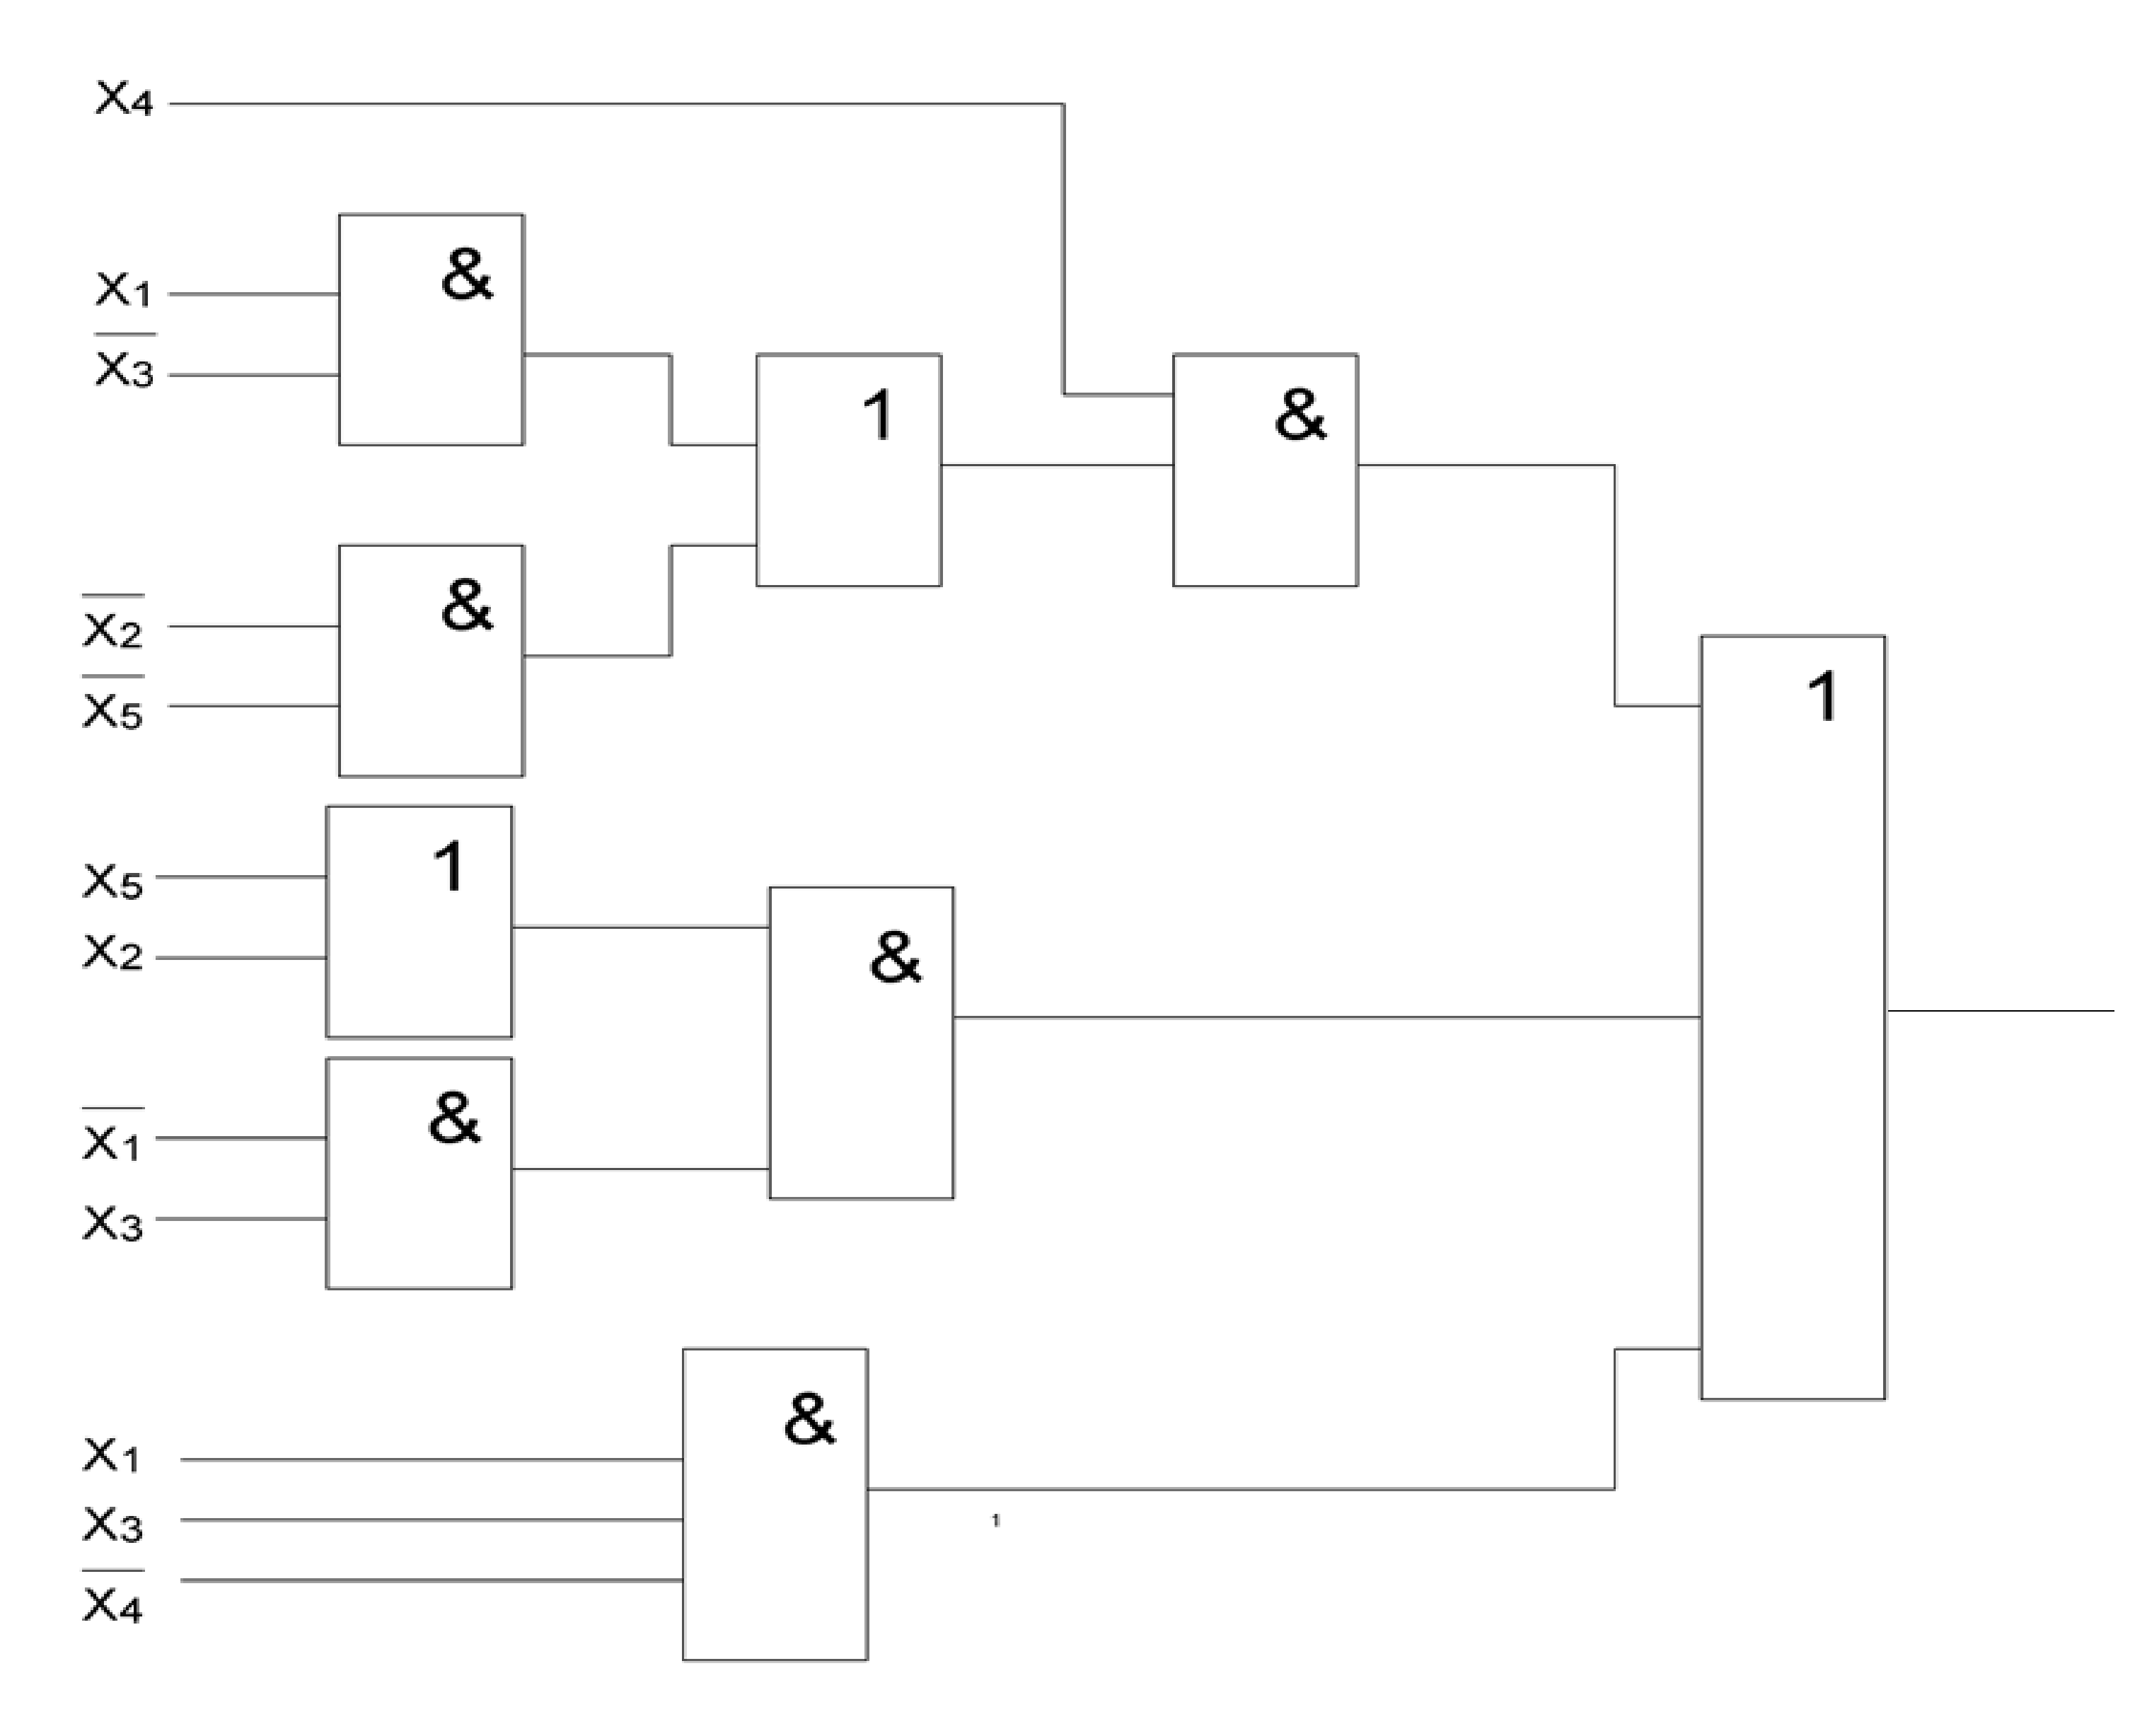

Задержка схемы T = 4t, цена схемы Sq = 19

Построение схемы в булевом базисе с однофазными входами:

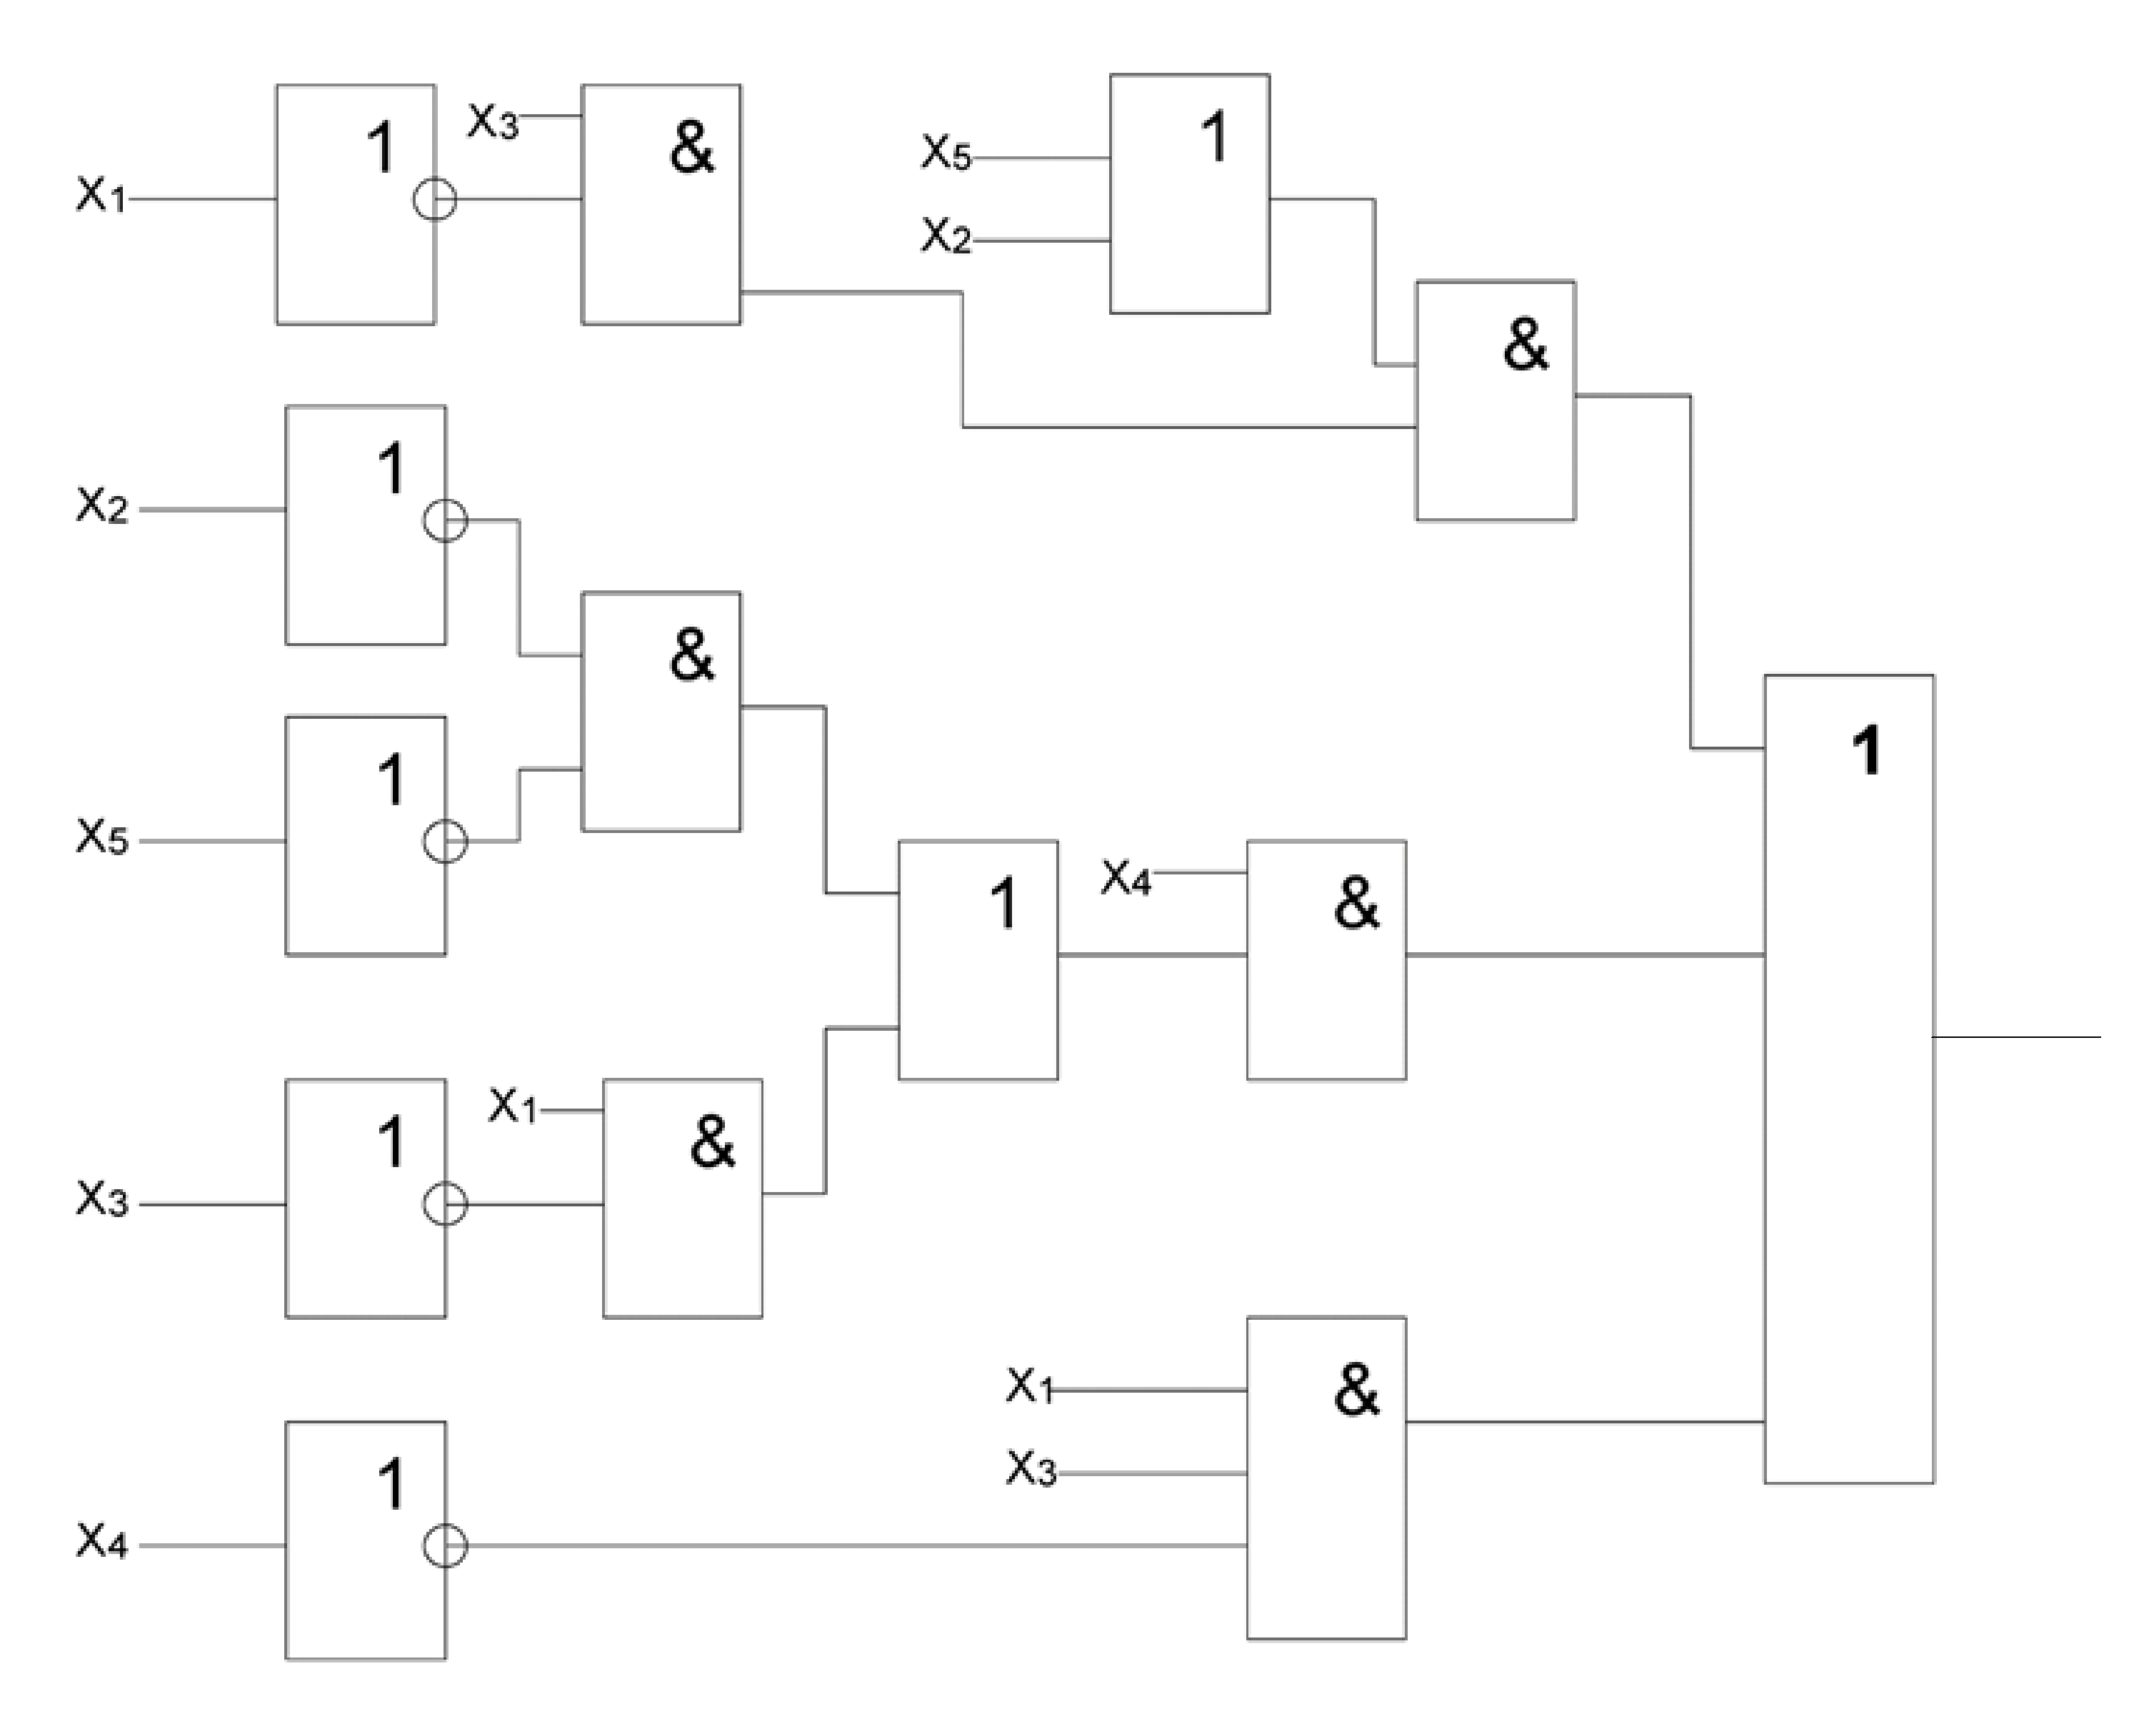

Задержка схемы T = 5t, цена схемы Sq = 24

**7.Синтез комбинационных схем в универсальных базисах**

Базис (ИЛИ-НЕ)

F= X4(X13 v25 )v 1X3(X5 v X2 ) v X1X34  = ((X4 ((X1X3) (X2X5)) ((X1X3) (X5X2)))

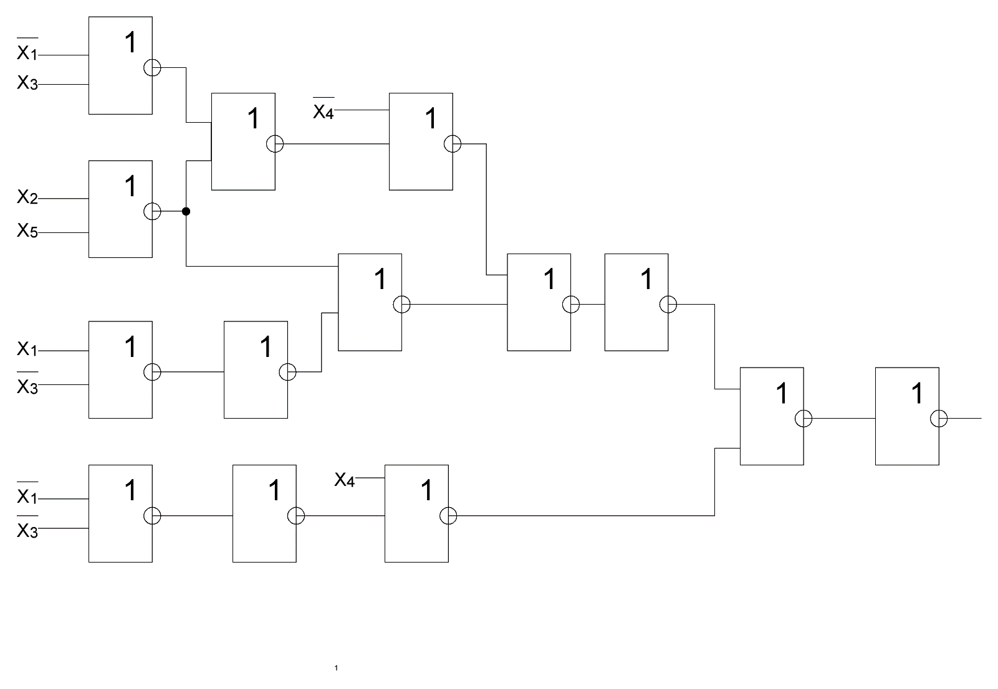((X1X3)X4))

Задержка схемы T = 7t, цена схемы Sq = 22

Преобразование схемы из булева базиса в универсальный

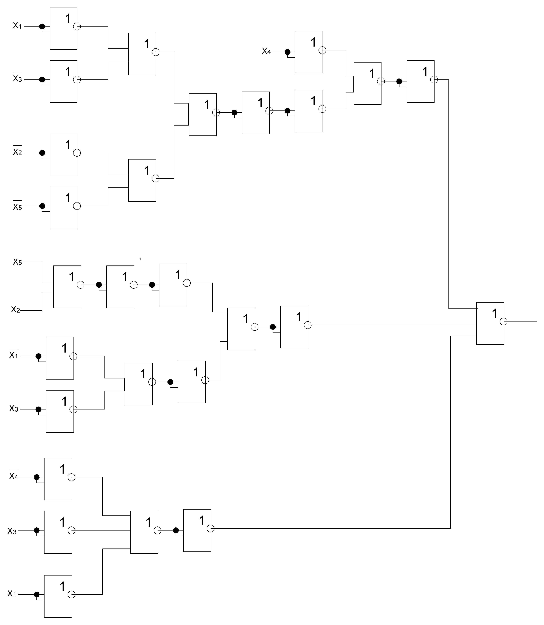

Базис (И-НЕ)

F=((X4|((X1|X3)|(X2|X5)))|((X1|X3)|(X5|X2)))|((X1|X3)|X4)

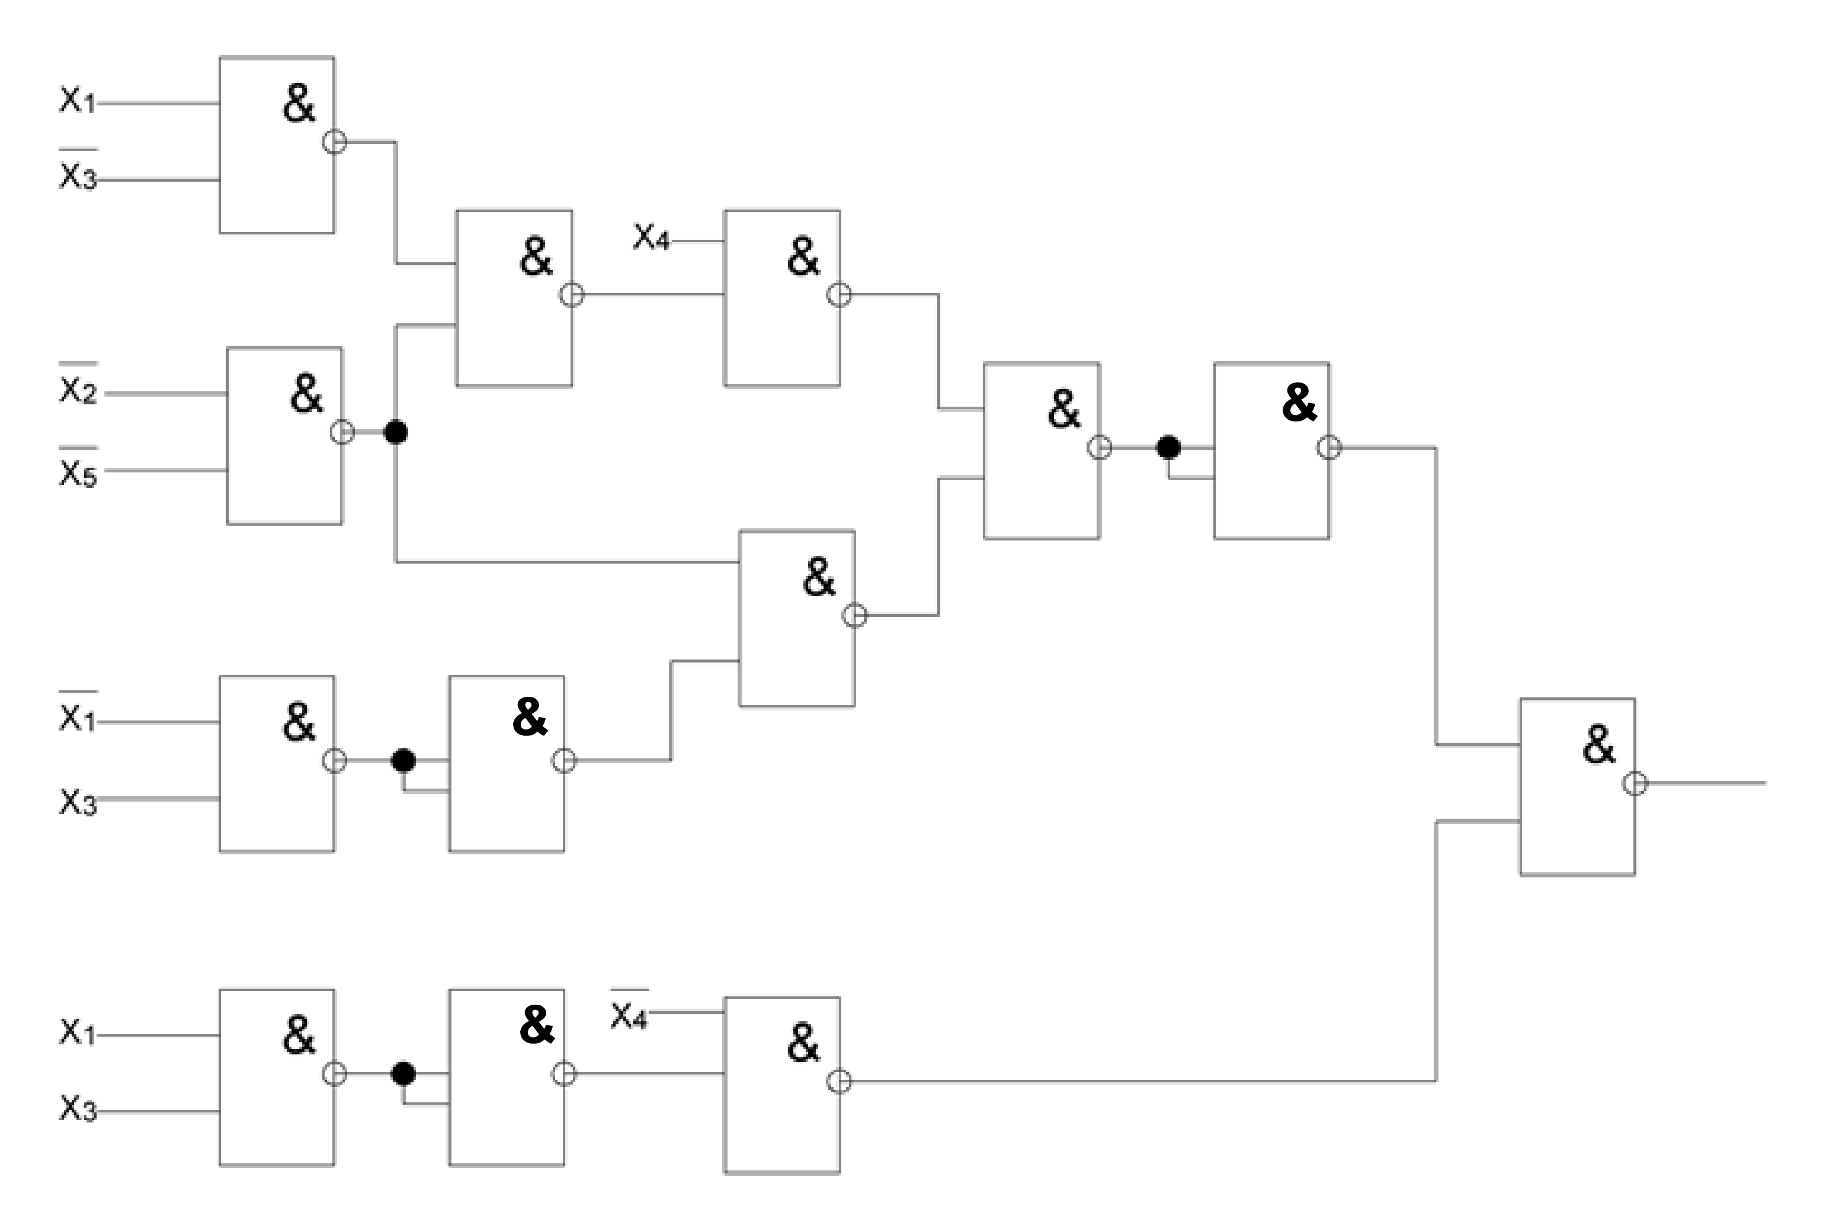

Задержка схемы T = 6t, цена схемы Sq = 21

Преобразование схемы из булева базиса в универсальный

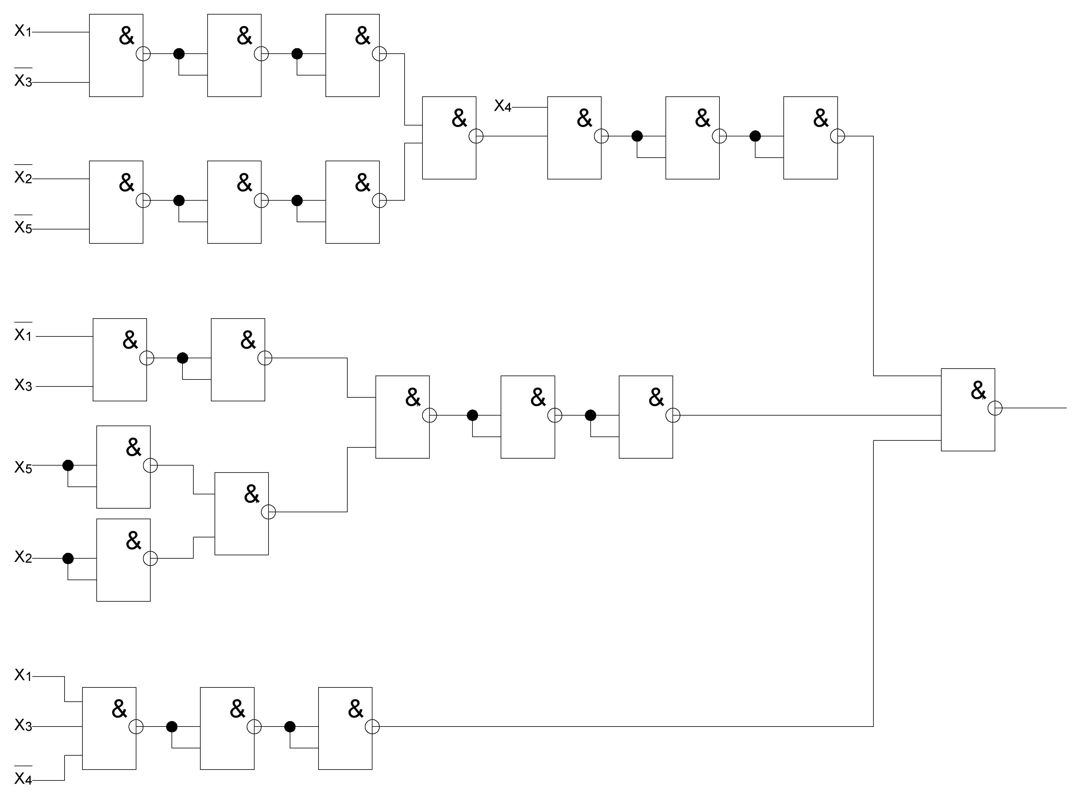

1. **Синтез комбинационных схем в сокращенных**

**булевых базисах**

Построение схемы в сокращённом базисе или, не:

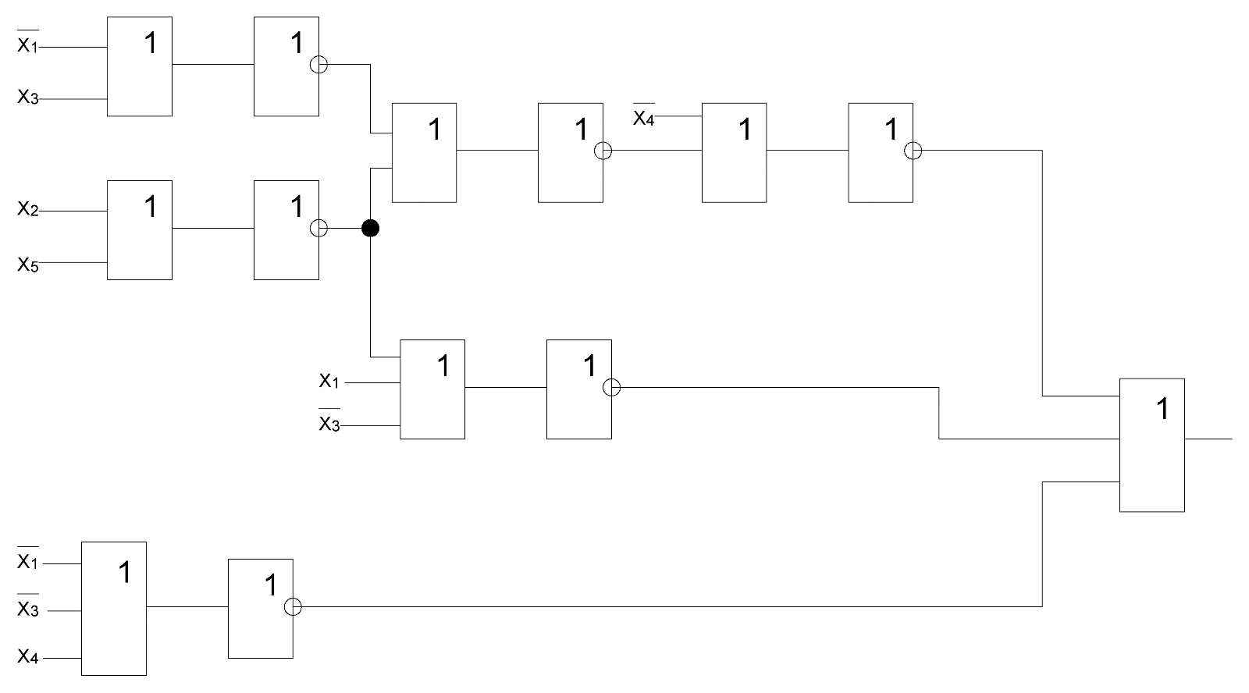F=(X4v((X2vX5)v(X1vX3)))v(X1vX3v(X5vX2))v(X1vX3vX4)

Задержка схемы: T = 7t Цена схемы: Sq=21

Построение схемы в сокращённом базисе и, не:

F=(X4*((X1*X3)*(X2*X5)))*((X5*X2)*X1*X3)*X1X3X4

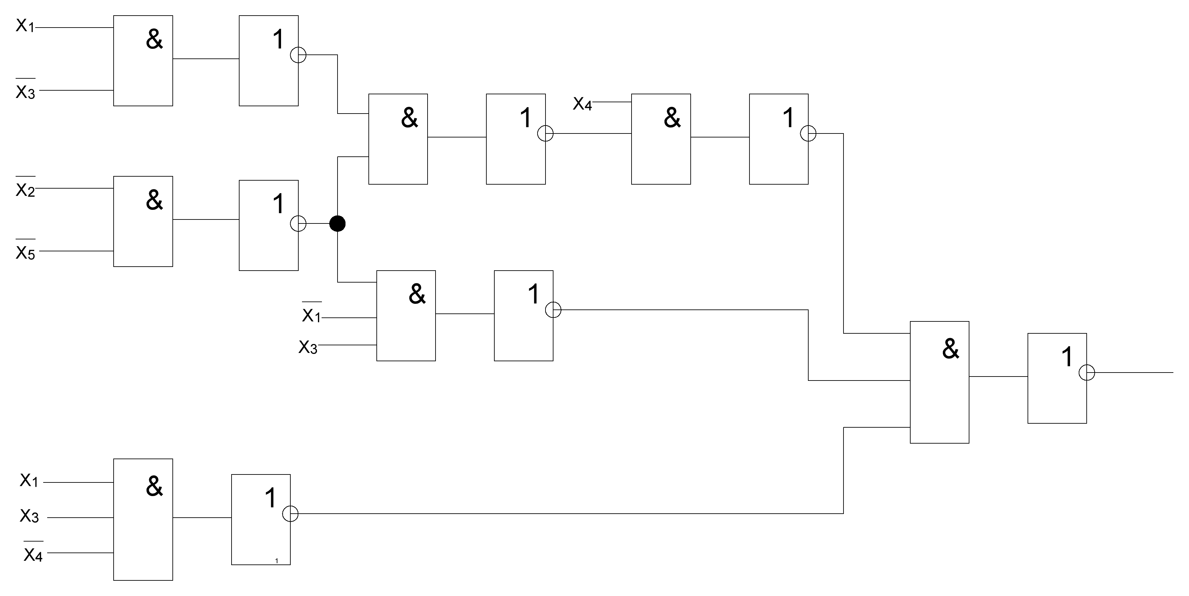

Задержка схемы: T = 8t Цена схемы: Sq=22